**UI/UX PROJECT**

**(2021-2022)**

**FOODY WEBSITE**



**Institute of Engineering & Technology**

**Submitted by:** Anshika Gupta (181500106)

**Index**

|  |  |  |
| --- | --- | --- |
| **S.no** | **Content** | **Page No.** |
| 1. | Abstract | 3 |
| 2. | Feasibility | 3 |
| 3. | Software Requirements | 3 |
| 4. | Hardware Requirements | 3 |
| 5. | Scope | 3 |
| 6. | Technologies | 4 |
| 7. | Implementation Details   * First Phase [Layout Design] * Second Phase [Coding] * Third Phase [Problem Solving] | 5 |
| 8. | Code Screen Shots | 6 |
| 9. | Screen Shots final project | 8 |
| 10. | Supported Platforms and Environment | 13 |
| 11. | Future Work | 13 |
| 12 | Live Project Link | 13 |
| 12. | GitHub Repo Link | 13 |

**Abstract**

The aim of this project was to build a responsive UI/UX Layout of online websites for restaurant which helps customers to order foods online. This Foody Website can be accessed through devices with different size of screens. One of big problem while ordering online is trust. Social Media websites play a vital role to attract customers and make trust on their mind. This website will allow hotels and restaurants to increase scope of business by reducing the labor cost involved.

**Feasibility**

The project requires a complete web application for restaurant that can be used to manage online orders. This will be mobile-optimized web app, so that it can be viewed in a mobile browser as well as in a PC.

**Software Requirements**

* Operating System: Windows XP/ Vista/ 7/ 8/ 10
* Android lollipop 5.0 and above

**Hardware Requirements**

* Processor: Intel i5
* Ram: 4GB

**Scope**

* Web application for restaurant.
* Online restaurant management system.
* Online food ordering system.
* Online customer management.

**Technologies**

1. **HTML** 

Hypertext Markup Language (HTML) is the standard markup language for documents designed to be displayed in a web browser. It can be assisted by technologies such as Cascading Style Sheets (CSS) and scripting languages such as JavaScript. Web browsers receive HTML documents from a web server or from local storage and render the documents into multimedia web pages. HTML describes the structure of a web page semantically and originally included cues for the appearance of the document.

HTML elements are the building blocks of HTML pages. With HTML constructs images and other objects such as interactive forms may be embedded into the rendered page. HTML provides a means to create structured documents by denoting structural semantics for text such as headings, paragraphs, lists, links, quotes and other items. HTML elements are delineated by tags, written using angle brackets. Tags such as

<img /> and <input /> directly introduce content into the page. Other tags such as <p> surround and provide information about document text and may include other tags as sub-elements. Browsers do not display the HTML tags, but use them to interpret the content of the page.

## CSS Css icon

Cascading Style Sheets (CSS) is a style sheet language used for describing the presentation of a document written in a markup language like HTML.CSS is a cornerstone technology of the World Wide Web, alongside HTML and JavaScript.CSS is designed to enable the separation of presentation and content, including layout, colors, and fonts. This separation can improve content accessibility, provide more flexibility and control in the specification of presentation characteristics, enable multiple web pages to share formatting by specifying the relevant CSS in a separate .css file, and reduce complexity and repetition in the structural content.

## JavaScript JavaScript icon

JavaScript s a high-level, interpreted scripting language that conforms to the ECMAScript specification. JavaScript has curly-bracket syntax, dynamic typing, prototype-based object-orientation, and first-class functions. Alongside HTML and CSS, JavaScript is one of the core technologies of the World Wide Web. JavaScript enables interactive web pages and is an essential part of web applications. The vast majority of websites use it, and major web browsers have a dedicated JavaScript engine to execute it. As a multi-paradigm language, JavaScript supports event-driven, functional, and imperative (including object- oriented and prototype-based) programming styles. It has APIs for working with text, arrays, dates, regular expressions, and the DOM, but the language itself does not include any I/O, such as networking, storage, or graphics facilities. It relies upon the host environment in which it is embedded to provide these features.

1. **Bootstrap –**

The primary purpose of adding it to a web project is to apply Bootstrap's choices of colour, size, font and layout to that project. As such, the primary factor is whether the developers in charge find those choices to their liking. Once added to a project, Bootstrap provides basic style definitions for all [HTML elements](https://en.wikipedia.org/wiki/HTML_element). The result is a uniform appearance for prose, tables and form elements across [web browsers](https://en.wikipedia.org/wiki/Web_browser). In addition, developers can take advantage of CSS classes defined in Bootstrap to further customize the appearance of their contents. For example, Bootstrap has provisioned for light- and dark-coloured tables, page headings, more prominent pull quotes, and text with a highlight. In our project we have used bootstrap while creation of login and sign-up form.

**Implementation Details**

I completed this project in mainly 3 parts –

* Layout Design
* Coding
* Problem solving

**First Phase (Layout Design)** –

In this phase I made a rough sketch of the design of the websites by researching various food ordering websites and divide the website into 8 sections –

* + - * + Home
        + Special
        + About
        + Dishes
        + Chief
        + Review
        + Order
        + Contact

**Second Phase (Coding)** –

In this phase I do coding part with the help of stack overflow and w3 schools according to layout which I designed.

Here below are some screen shots of our code –

**HTML Code SS -**

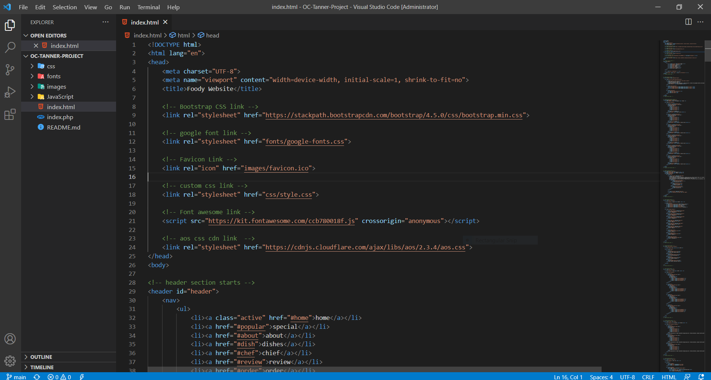

**JavaScript Code SS -**

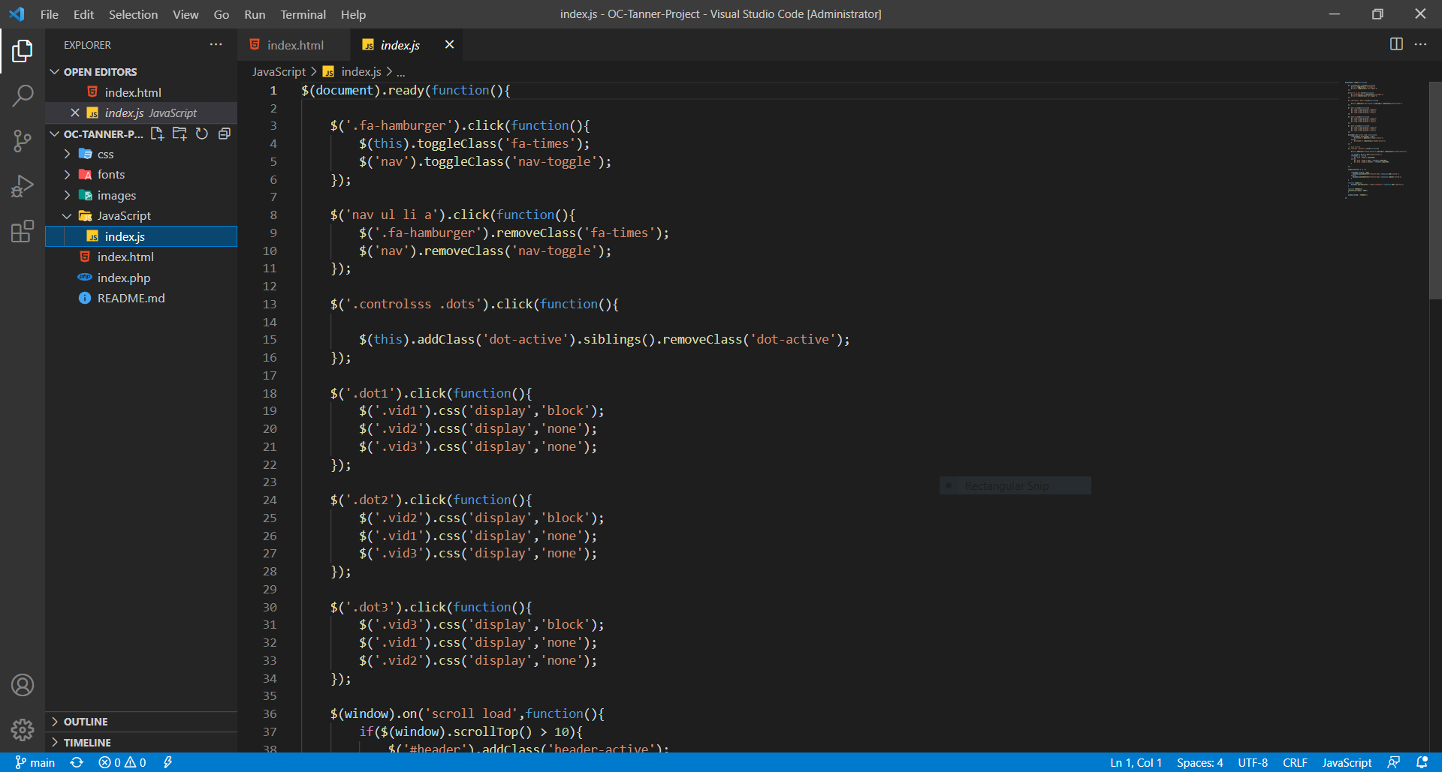

**CSS Code SS -**

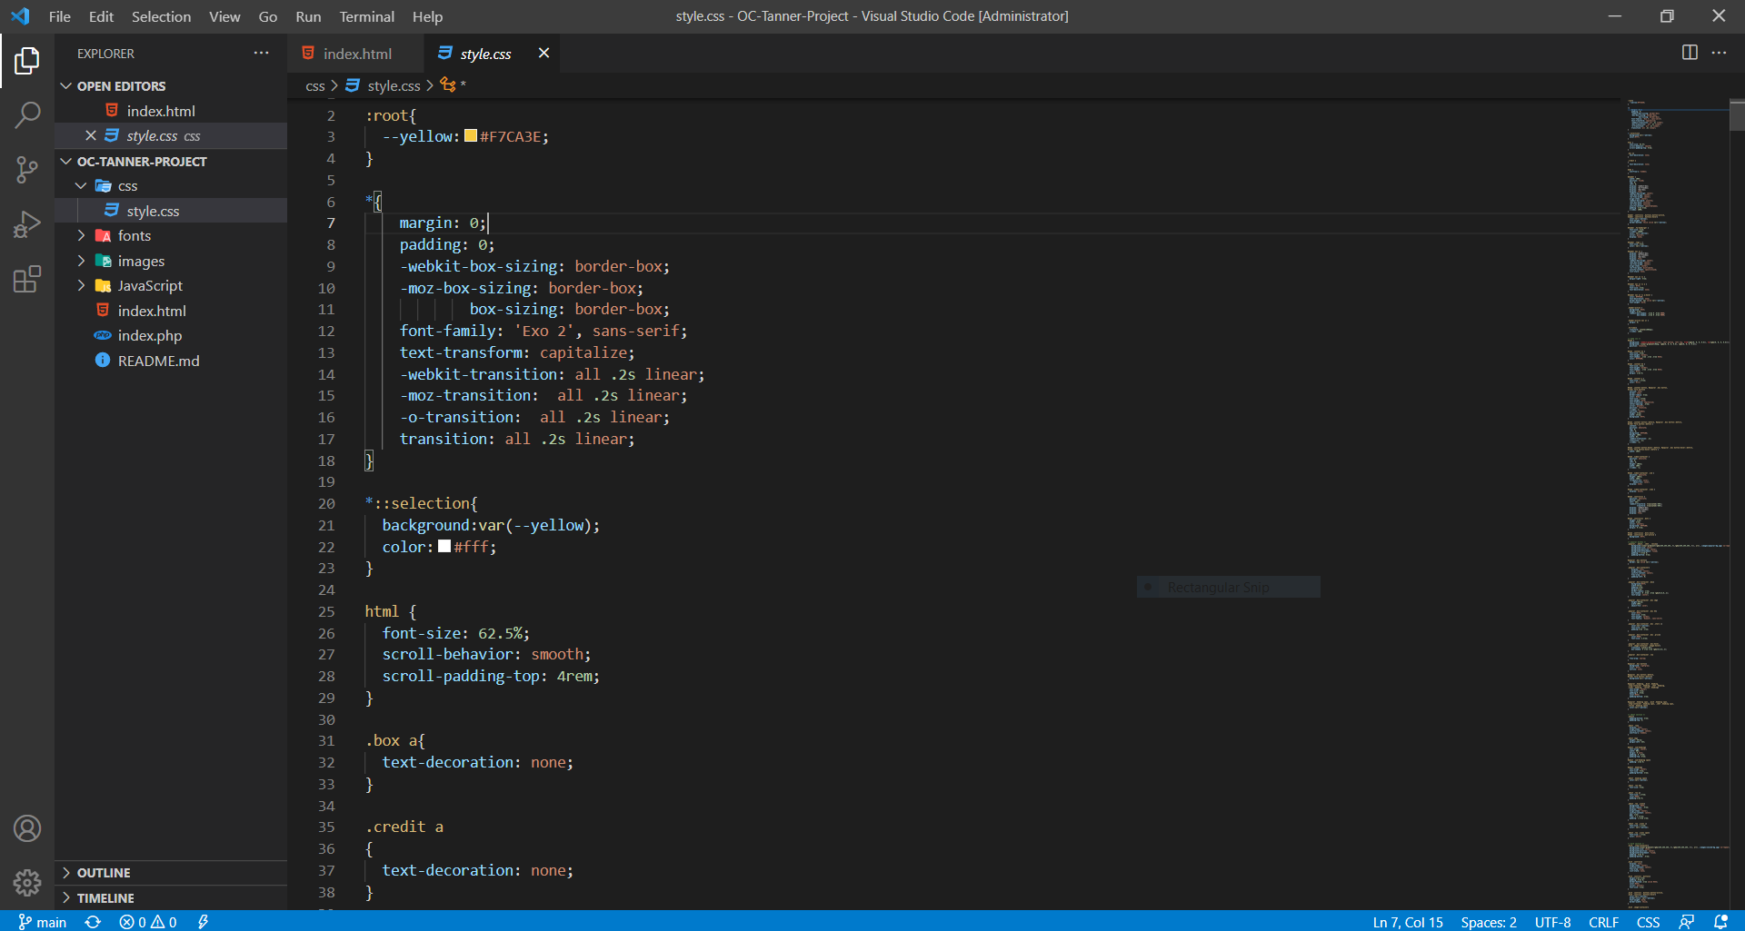

**Third phase (Problem Solving)** –

During this phase when I was about to complete my project I faced some difficulties. Such as –

* Layout overlapped
* Responsiveness
* Animations was not proper working.

But **I overcomed** with these difficulties with the help of stack overflow, w3 schools and google.

And finally here are some **Screen Shots of final project** –

**Home** –

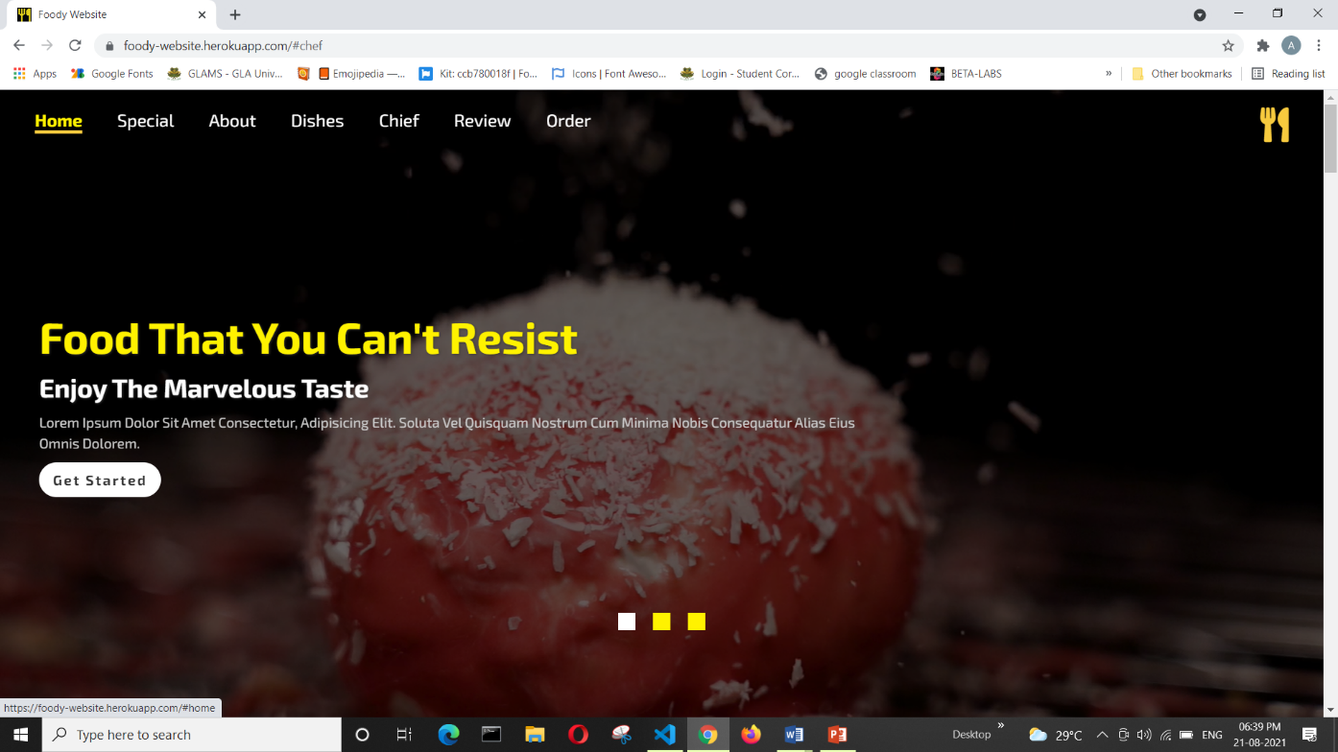

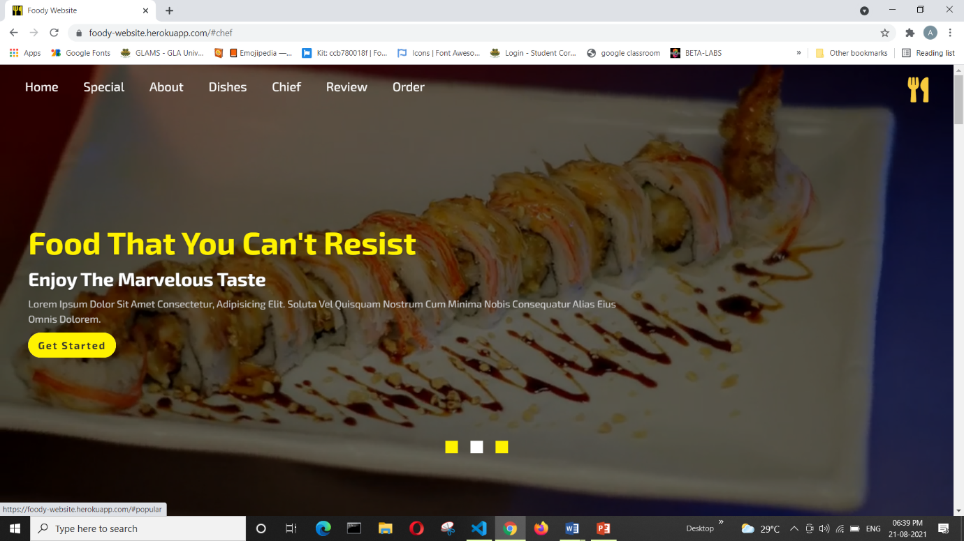

**Special -**

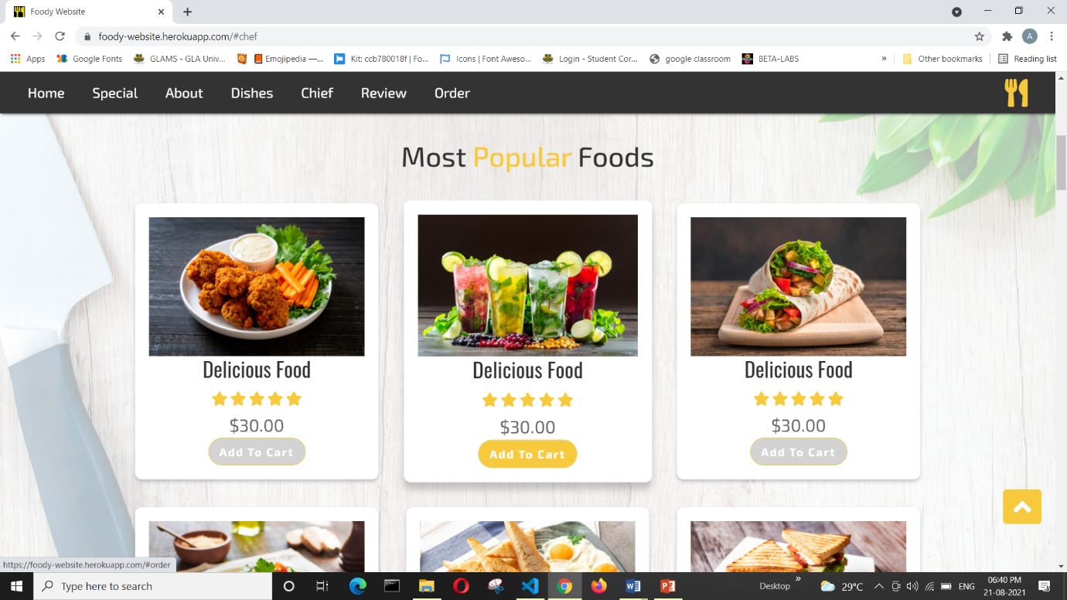

**About -**

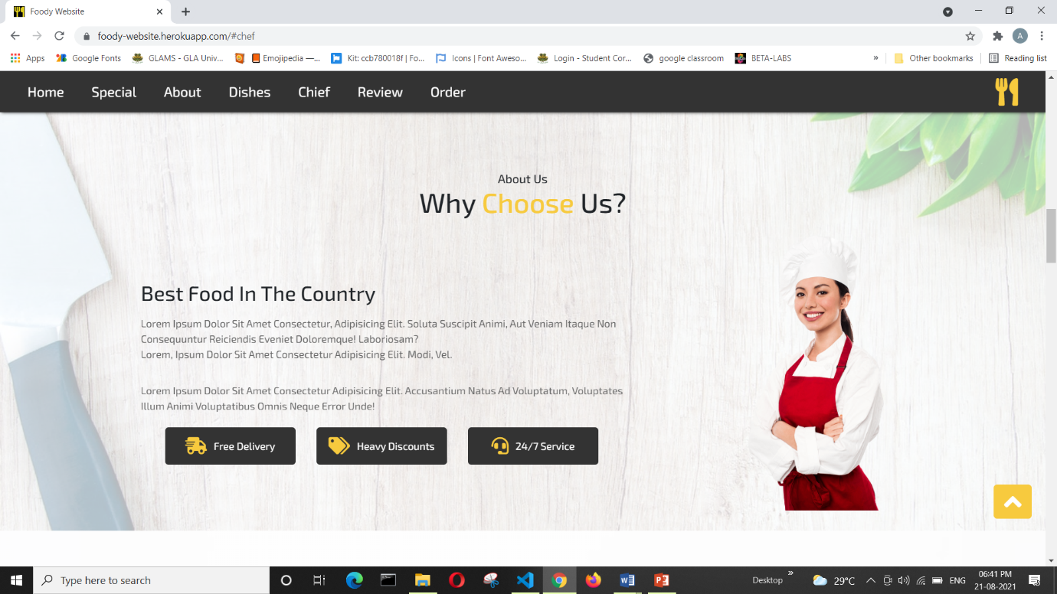

**Dishes -**

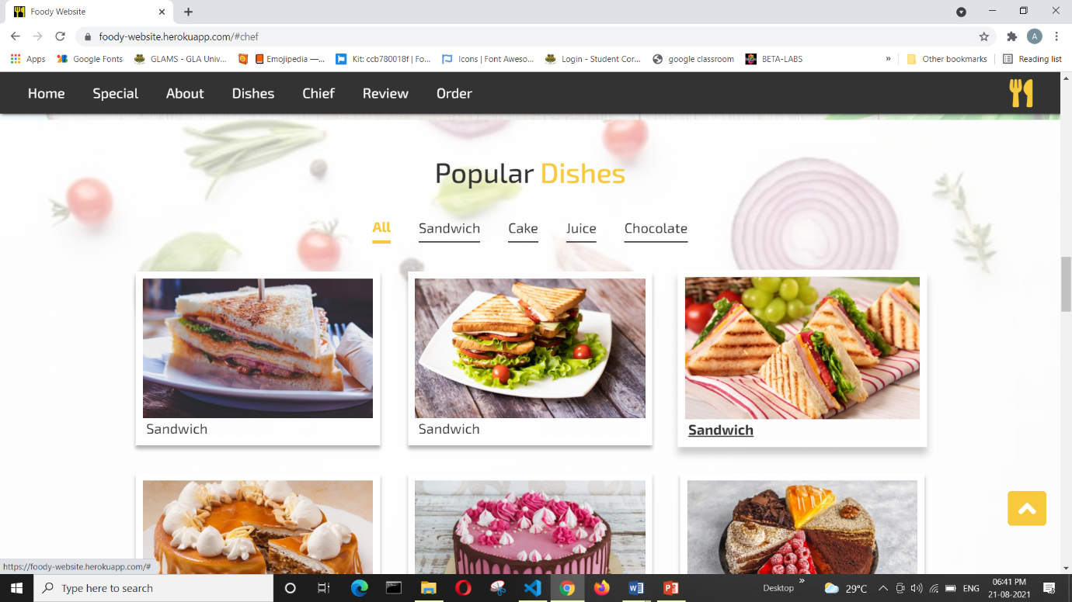

**Works -**

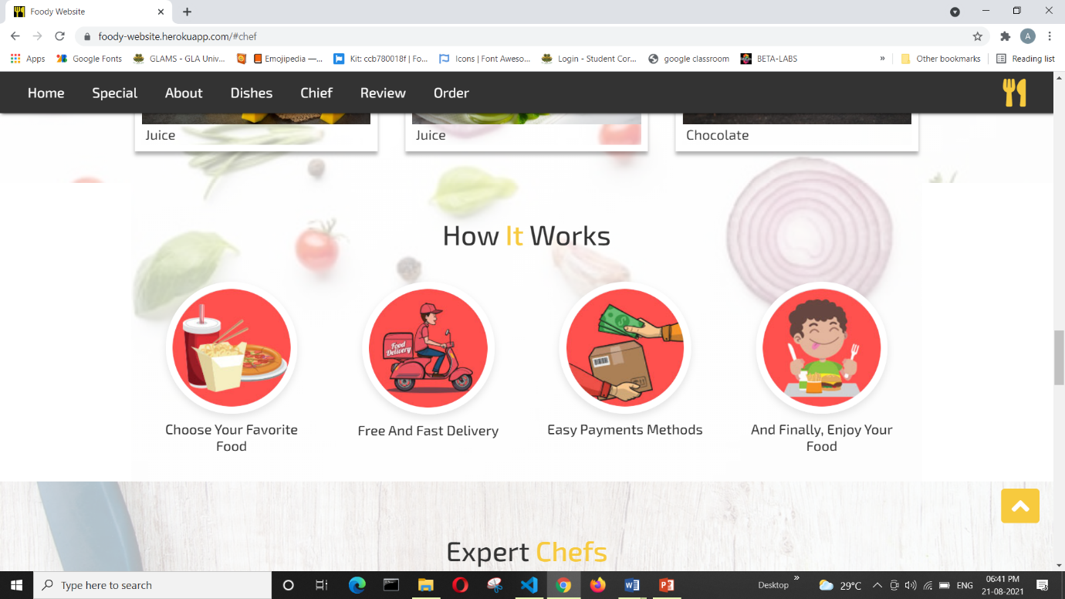

**Chief -**

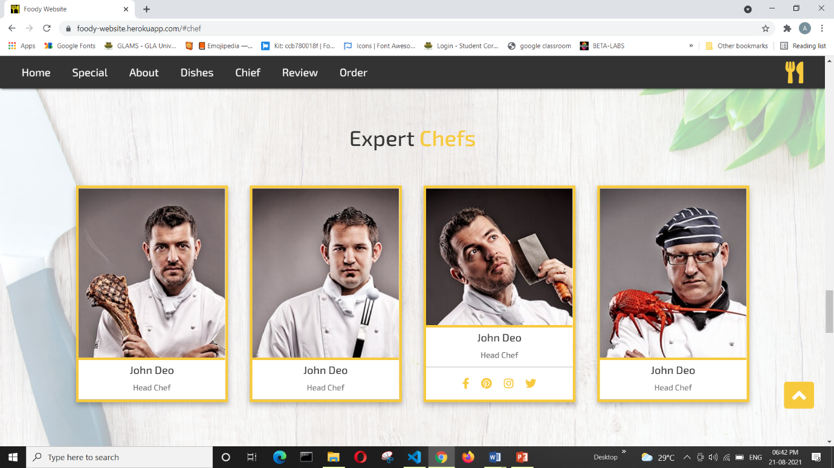

**Reviews -**

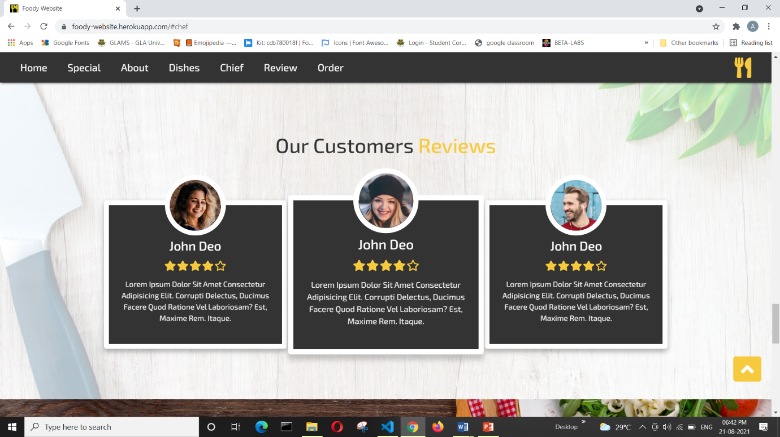

**Order -**

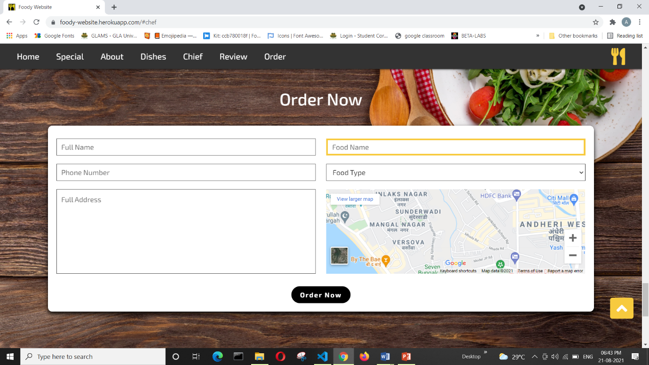

**Contact -**

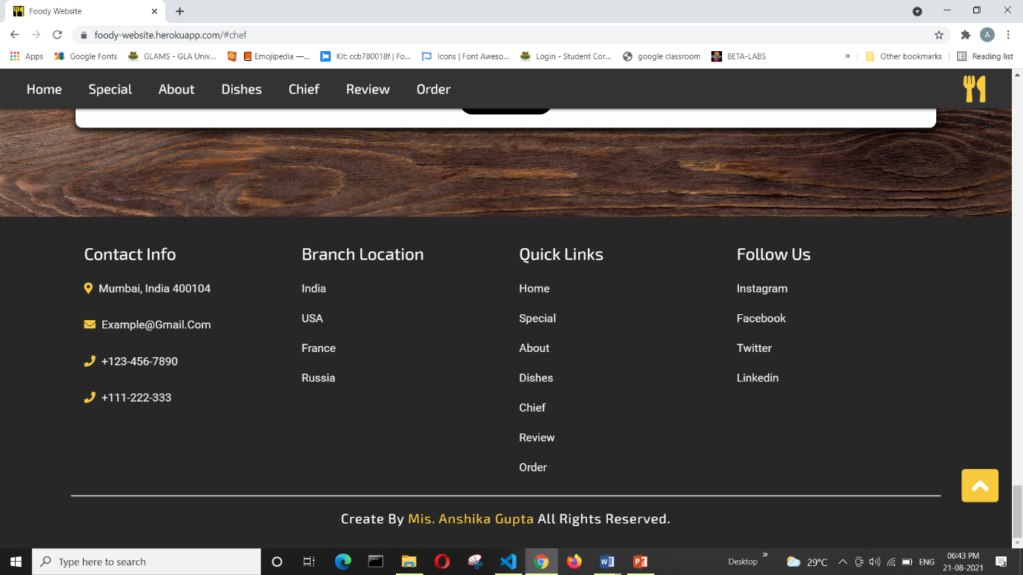

**Supported Platforms and Environment**

* Google Chrome
* Mozilla Firefox
* Opera
* Microsoft Edge

**Future Work**

The following section describes the work that will be implemented in future –

* Customize orders – Allow customers to customize food orders.
* Enhances User Interface by adding more user interactive features. Provide Deals and Promotional Offer details to home page. Provide Recipes of the Week/Day to Home Page.
* Payment Options – Add different payment options such as PayPal, Cash, Gift Cards etc. Allow to save payment details for future use.
* Allow to process an order as a Guest.
* Delivery Options – Add delivery option
* Order Status – Show only Active orders to Restaurant Employees.
* Order Ready Notification – Send an Order Ready notification to the customer.

**Live Project Link**

* [**https://anshika1301.github.io/OC-Tanner-Project/**](https://anshika1301.github.io/OC-Tanner-Project/)
* [**https://foody-website.herokuapp.com/**](https://foody-website.herokuapp.com/)

**GitHub Repo Link**

<https://github.com/Anshika1301/OC-Tanner-Project>

**THANK YOU**